**SSN College of Engineering, Kalavakkam**

**Department of Computer Science and Engineering**

**UCS1711-Mobile Application Development Lab**

**Exercise 7:Andriod Location Tracker Application**

**Name : S.NACHAMMAI DEVI POOJA**

**Class :CSE Sec: B**

**Reg no: 185001096**

**AIM:**

To develop an android Location Tracker Application.

**CODE:**

MainActivity.java:

package com.example.gpslocation;

import androidx.appcompat.app.AppCompatActivity;

import androidx.core.app.ActivityCompat;

import androidx.core.content.ContextCompat;

import android.Manifest;

import android.content.Context;

import android.content.pm.PackageManager;

import android.location.LocationListener;

import android.location.LocationManager;

import android.os.Bundle;

import android.util.Log;

import android.view.View;

import android.widget.Button;

import android.widget.EditText;

import java.util.List;

public class MainActivity extends AppCompatActivity {

EditText lat, lon;

private GPSTracker gpsTracker;

@Override

protected void onCreate(Bundle savedInstanceState) {

super.onCreate(savedInstanceState);

setContentView(R.layout.activity_main);

Button track = (Button) findViewById(R.id.track_btn);

lat = (EditText) findViewById(R.id.lat);

lon = (EditText) findViewById(R.id.lon);

try {

if (ContextCompat.checkSelfPermission(getApplicationContext(), android.Manifest.permission.ACCESS_FINE_LOCATION) != PackageManager.PERMISSION_GRANTED ) {

ActivityCompat.requestPermissions(this, new String[]{android.Manifest.permission.ACCESS_FINE_LOCATION}, 101);

}

} catch (Exception e){

e.printStackTrace();

}

track.setOnClickListener(new View.OnClickListener() {

@Override

public void onClick(View view) {

gpsTracker = new GPSTracker(MainActivity.this);

if(gpsTracker.canGetLocation()){

Log.i("MainActivity","Success");

double latitude = gpsTracker.getLatitude();

double longitude = gpsTracker.getLongitude();

lat.setText(String.valueOf(latitude));

lon.setText(String.valueOf(longitude));

}else{

Log.i("MainActivity","Failure");

gpsTracker.showSettingsAlert();

}

}

});

}

}

activity_main.xml:

<?xml version="1.0" encoding="utf-8"?>

<androidx.constraintlayout.widget.ConstraintLayout xmlns:android="http://schemas.android.com/apk/res/android"

xmlns:app="http://schemas.android.com/apk/res-auto"

xmlns:tools="http://schemas.android.com/tools"

android:layout_width="match_parent"

android:layout_height="match_parent"

android:orientation="vertical"

tools:context=".MainActivity">

<EditText

android:id="@+id/lat"

android:layout_width="wrap_content"

android:layout_height="wrap_content"

android:layout_marginTop="184dp"

android:ems="10"

android:inputType="textPersonName"

android:text="Latitude"

app:layout_constraintEnd_toEndOf="parent"

app:layout_constraintHorizontal_bias="0.875"

app:layout_constraintStart_toStartOf="parent"

app:layout_constraintTop_toTopOf="parent" />

<EditText

android:id="@+id/lon"

android:layout_width="wrap_content"

android:layout_height="wrap_content"

android:layout_marginTop="80dp"

android:layout_marginEnd="4dp"

android:ems="10"

android:inputType="textPersonName"

android:text="Longitude"

app:layout_constraintEnd_toEndOf="@+id/lat"

app:layout_constraintTop_toBottomOf="@+id/lat" />

<Button

android:id="@+id/button3"

android:layout_width="wrap_content"

android:layout_height="wrap_content"

android:backgroundTint="#2E3B81"

android:text="Longitude"

app:layout_constraintBottom_toBottomOf="parent"

app:layout_constraintEnd_toEndOf="parent"

app:layout_constraintHorizontal_bias="0.054"

app:layout_constraintStart_toStartOf="parent"

app:layout_constraintTop_toTopOf="parent"

app:layout_constraintVertical_bias="0.448" />

<Button

android:id="@+id/track_btn"

android:layout_width="wrap_content"

android:layout_height="wrap_content"

android:layout_marginBottom="207dp"

android:backgroundTint="#2338AC"

android:text="Get Location"

app:layout_constraintBottom_toBottomOf="parent"

app:layout_constraintEnd_toEndOf="parent"

app:layout_constraintStart_toStartOf="parent" />

<Button

android:id="@+id/button2"

android:layout_width="wrap_content"

android:layout_height="wrap_content"

android:backgroundTint="#2E3B81"

android:text="Lattitude"

app:layout_constraintBottom_toBottomOf="parent"

app:layout_constraintEnd_toEndOf="parent"

app:layout_constraintHorizontal_bias="0.04"

app:layout_constraintStart_toStartOf="parent"

app:layout_constraintTop_toTopOf="parent"

app:layout_constraintVertical_bias="0.267" />

<Button

android:id="@+id/button"

android:layout_width="387dp"

android:layout_height="73dp"

android:backgroundTint="#276987"

android:text="Android Location Tracker Application"

app:layout_constraintEnd_toEndOf="parent"

app:layout_constraintHorizontal_bias="0.5"

app:layout_constraintStart_toStartOf="parent" />

</androidx.constraintlayout.widget.ConstraintLayout>

Colors.xml:

<?xml version="1.0" encoding="utf-8"?>

<resources>

<color name="purple_200">#FFBB86FC</color>

<color name="purple_500">#FF6200EE</color>

<color name="purple_700">#FF3700B3</color>

<color name="teal_200">#FF03DAC5</color>

<color name="teal_700">#FF018786</color>

<color name="black">#FF000000</color>

<color name="white">#FFFFFFFF</color>

</resources>

GPSTracker.java:

package com.example.gpslocation;

import android.Manifest;

import android.app.Activity;

import android.app.AlertDialog;

import android.app.Service;

import android.content.Context;

import android.content.DialogInterface;

import android.content.Intent;

import android.content.pm.PackageManager;

import android.location.Location;

import android.location.LocationListener;

import android.location.LocationManager;

import android.os.Bundle;

import android.os.IBinder;

import android.provider.Settings;

import android.util.Log;

import androidx.core.app.ActivityCompat;

public class GPSTracker extends Service implements LocationListener {

private final Context mContext;

// flag for GPS status

boolean isGPSEnabled = false;

// flag for network status

boolean isNetworkEnabled = false;

// flag for GPS status

boolean canGetLocation = false;

Location location; // location

double latitude; // latitude

double longitude; // longitude

// The minimum distance to change Updates in meters

private static final long MIN_DISTANCE_CHANGE_FOR_UPDATES = 10; // 10 meters

// The minimum time between updates in milliseconds

private static final long MIN_TIME_BW_UPDATES = 1000 * 60 * 1; // 1 minute

// Declaring a Location Manager

protected LocationManager locationManager;

public GPSTracker(Context context) {

this.mContext = context;

getLocation();

}

public Location getLocation() {

try {

locationManager = (LocationManager) mContext.getSystemService(LOCATION_SERVICE);

// getting GPS status

isGPSEnabled = locationManager.isProviderEnabled(LocationManager.GPS_PROVIDER);

// getting network status

isNetworkEnabled = locationManager

.isProviderEnabled(LocationManager.NETWORK_PROVIDER);

if (!isGPSEnabled && !isNetworkEnabled) {

// no network provider is enabled

} else {

this.canGetLocation = true;

// First get location from Network Provider

if (isNetworkEnabled) {

//check the network permission

if (ActivityCompat.checkSelfPermission(mContext, Manifest.permission.ACCESS_FINE_LOCATION) != PackageManager.PERMISSION_GRANTED && ActivityCompat.checkSelfPermission(mContext, Manifest.permission.ACCESS_COARSE_LOCATION) != PackageManager.PERMISSION_GRANTED) {

ActivityCompat.requestPermissions((Activity) mContext, new String[]{android.Manifest.permission.ACCESS_FINE_LOCATION, Manifest.permission.ACCESS_COARSE_LOCATION}, 101);

}

locationManager.requestLocationUpdates(

LocationManager.NETWORK_PROVIDER,

MIN_TIME_BW_UPDATES,

MIN_DISTANCE_CHANGE_FOR_UPDATES, this);

Log.d("Network", "Network");

if (locationManager != null) {

location = locationManager

.getLastKnownLocation(LocationManager.NETWORK_PROVIDER);

if (location != null) {

latitude = location.getLatitude();

longitude = location.getLongitude();

}

}

}

if (isGPSEnabled) {

if (location == null) {

if (ActivityCompat.checkSelfPermission(mContext, Manifest.permission.ACCESS_FINE_LOCATION) != PackageManager.PERMISSION_GRANTED && ActivityCompat.checkSelfPermission(mContext, Manifest.permission.ACCESS_COARSE_LOCATION) != PackageManager.PERMISSION_GRANTED) {

ActivityCompat.requestPermissions((Activity) mContext, new String[]{android.Manifest.permission.ACCESS_FINE_LOCATION, Manifest.permission.ACCESS_COARSE_LOCATION}, 101);

}

locationManager.requestLocationUpdates(

LocationManager.GPS_PROVIDER,

MIN_TIME_BW_UPDATES,

MIN_DISTANCE_CHANGE_FOR_UPDATES, this);

Log.d("GPS Enabled", "GPS Enabled");

if (locationManager != null) {

location = locationManager

.getLastKnownLocation(LocationManager.GPS_PROVIDER);

if (location != null) {

latitude = location.getLatitude();

longitude = location.getLongitude();

}

}

}

}

}

} catch (Exception e) {

e.printStackTrace();

}

return location;

}

public void stopUsingGPS(){

if(locationManager != null){

locationManager.removeUpdates(GPSTracker.this);

}

}

public double getLatitude(){

if(location != null){

latitude = location.getLatitude();

}

// return latitude

return latitude;

}

public double getLongitude(){

if(location != null){

longitude = location.getLongitude();

}

// return longitude

return longitude;

}

public boolean canGetLocation() {

return this.canGetLocation;

}

public void showSettingsAlert(){

AlertDialog.Builder alertDialog = new AlertDialog.Builder(mContext);

// Setting Dialog Title

alertDialog.setTitle("GPS is settings");

// Setting Dialog Message

alertDialog.setMessage("GPS is not enabled. Do you want to go to settings menu?");

// On pressing Settings button

alertDialog.setPositiveButton("Settings", new DialogInterface.OnClickListener() {

public void onClick(DialogInterface dialog,int which) {

Intent intent = new Intent(Settings.ACTION_LOCATION_SOURCE_SETTINGS);

mContext.startActivity(intent);

}

});

// on pressing cancel button

alertDialog.setNegativeButton("Cancel", new DialogInterface.OnClickListener() {

public void onClick(DialogInterface dialog, int which) {

dialog.cancel();

}

});

alertDialog.show();

}

@Override

public void onLocationChanged(Location location) {

}

@Override

public void onProviderDisabled(String provider) {

}

@Override

public void onProviderEnabled(String provider) {

}

@Override

public void onStatusChanged(String provider, int status, Bundle extras) {

}

@Override

public IBinder onBind(Intent arg0) {

return null;

}

}

**OUTPUT:**

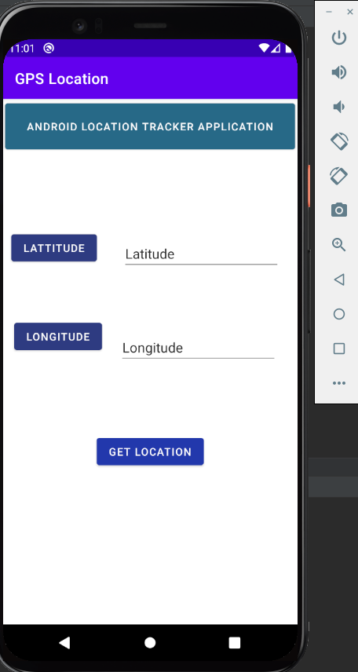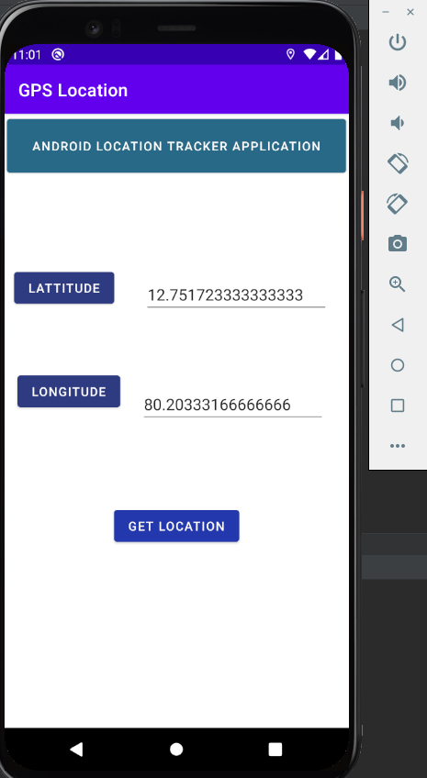

**RESULT:**

An android Location Tracker Application has been successfully developed.